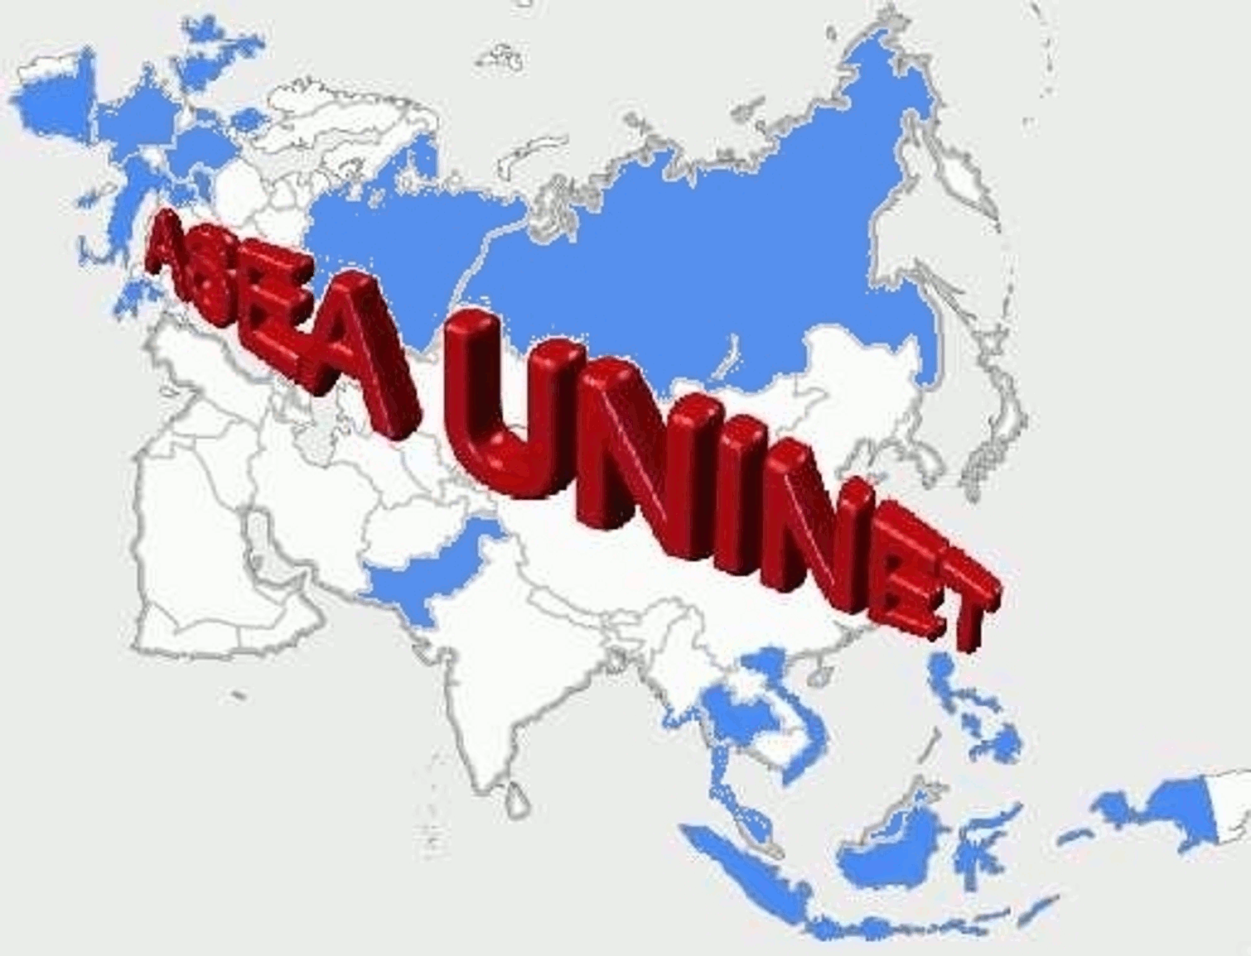
The Bernd Rode Award is awarded to outstanding scientific and higher education collaborations between European and South-East-Asian universities in the framework of ASEA-UNINET. The award is granted every 18 months in three different categories.

Bernd Rode Award 2015
Call for Award

The award is named after Bernd Michael Rode an eminent Austrian researcher and founder of the Austrian-South-East-Asian Academic University Network (ASEA-UNINET).

The Award is associated with financial support up to a maximum of 5.000 € to enhance and extend the research possibilities within ASEA-UNINET supported projects (e.g. travel expenses, research stay).

Guidelines

- The award is granted in the following three categories
  - Junior (Individual contributions conducted within the framework of ASEA-UNINET of applicants up to 5 years after PhD)
  - Senior (Individual contributions, including all publications and projects conducted in the frame of ASEA-UNINET of applicants over 5 years after PhD)
  - Project-based collaborative research conducted in the framework of ASEA-UNINET

- University staff in the field of arts are as well highly welcome to submit in the three categories mentioned above.

- The submitted projects and contributions must have been at least partially funded by ASEA-UNINET after the year 2011 (e.g. research-stay, scholarship, etc.).

- The awarded prize money has to be reinvested into an ASEA-UNINET supported project.

Submissions

Submissions are to be sent by email to office@asea-uninet.org and should include the following documents.

- Junior and Senior submissions:
  - Short description (about 5 pages)
  - Role of ASEA-UNINET for the work of the applicant
  - CV and publication list (+ the applicants’ 5 best publications as full PDF-Version)
  - The three most important scientific or artistic contributions of the applicant (max. 200 Words
- Project-based submissions:
  - Short project description (about 5 pages)
  - Role of ASEA-UNINET as facilitator
  - CV and publication list of the project team
  - Scientific and/or societal education results and publications stemming out of the project

Important Dates

Submission deadline: November 15th, 2015
Notification Deadline: January 15th, 2016
Award Ceremony / ASEA-UNINET Plenary Meeting 2016: February 2016

